Evaluation of Pixhawk-Based Quadcopter Flight Performance: “A Comprehensive Testing Approach”

**Sai Rohan P.1, Dileep Kumar S.1, Khwaja Moinuddin S.1, Pavani N.1**

**Dr. K. K. Deepika2**

*1B. Tech, Dept of EEE, Vignan’s Institute of Information Technology (A), Visakhapatnam, India*.

*2Assistant Professor, Dept of EEE, Vignan’s Institute of Information Technology (A), Visakhapatnam, India.*

## Abstract

This study presents the results of flight testing conducted to evaluate the performance of a quadcopter under various operational conditions. The aim of the study was to evaluate the quadcopter's performance under standard flight conditions and its reaction to external stimuli such wind direction and speed. Acceleration graphs showing flight length, altitude stability, and system reaction were among the data gathered during testing. The quadcopter exhibited effective flying characteristics by keeping a steady hover and reacting quickly to directions from ground control. Nonetheless, anomalies from the intended behaviour were noted, especially in settings with strong winds, which resulted in mistakes related to parameter deviations, like disparities in height between 10 and 20 meters. Data analysis showed that it was more practical to achieve altitude and stability with reduced variation with payload weights under 250g. the outcomes provide significant understanding of the quadcopter's performance attributes and indicate avenues for additional investigation. These discoveries advance our knowledge of autonomous aerial systems and offer suggestions for enhancing their general manoeuvrability and dependability.

## 1. Introduction to Pixhawk-Based Quadcopters:

To guarantee the Pixhawk-based quadcopter's operational dependability, safety, and performance in a variety of real-world circumstances, testing is essential. This assessment step entails a thorough analysis and verification of the quadcopter's flight performance, stability, precision of navigation, and reaction to environmental stimuli. The quadcopter's design, control algorithms, and operating procedures are refined as a result of the insights gained into its behavior under various flying situations through rigorous testing processes.

Pixhawk-powered quadcopters are put through rigorous testing that includes a range of flight modes, maneuvers, and climatic conditions. These tests evaluate the hovering stability, user input response, position hold accuracy, endurance, and adaptation to wind disturbances and payload fluctuations.

**Overview of Pixhawk Flight Controller:**

Based on previously published works and technical datasheet, which provided a thorough overview of Pixhawk flight controllers, including their architecture, features, and capabilities.

In the world of unmanned aerial vehicles (UAVs), the Pixhawk flight controller is a key piece of technology that is well-known for its dependability, adaptability, and rich feature set. The Pixhawk autopilot, which acts as the central processing unit in charge of flight control, navigation, and communication, is the foundation of the Pixhawk ecosystem.

One of the most recent versions of the Pixhawk series, Precise and autonomous flying operations are made possible by its small size and powerful architecture, which combines a variety of sensors, interfaces, and communication protocols.

Pixhawk 4.2.8 stands out because of its extensive range of pinouts and interfaces, which allow for easy integration with a wide range of peripheral devices and sensors. These consist of I2C and SPI interfaces for attaching external sensors and peripherals, PWM outputs for motor control, UART ports for telemetry and GPS modules, and specific ports for power distribution and battery monitoring. Users are empowered to increase the capabilities of their UAV systems to meet mission-specific needs by having access to such flexible connectivity choices.

Pixhawk 4.2.8 has an amazing selection of inbuilt sensors, including magnetometers, barometers, accelerometers, gyroscopes, and a high-precision GPS module. These sensors supply vital information for precise altitude control, navigation, stabilization, and attitude estimate, allowing the Pixhawk autopilot to maintain stability and agility even in difficult flying circumstances.

Pixhawk 4.2.8 allows for flexible communication setups catered to particular operational requirements by supporting a variety of telemetry options, such as Wi-Fi, Bluetooth, and long-range radio systems.

MAV Link enables smooth integration with mission planning software and ground control interfaces by facilitating real-time telemetry transmission, command and control functions, and data exchange.

## 2. Flight Testing Procedures:

Providing pre-flight checklists and safety procedures, such as equipment checks, battery inspections, and communication checks, which must be followed before every flight test to ensure safety of the quadcopter. These tests assess the quadcopter's ability to maintain a stable hover position without drifting or oscillating. In order to assess the quadcopter's stability in various flight systems, these tests may involve keeping the UAV stationary at varied elevations and orientations with respect to the wind velocity.

### Types of Tests

1. Altitude hold test
2. Stability test
3. Speed test
4. Payload test

### Altitude hold test

The altitude hold test is intended to assess the drone's stability during a sustained altitude hover. The UAV's flight controller uses the MS5611 barometer sensor to measure the ambient pressure and translate it into altitude. parameters for Pos.Alt and Gps.Alt. As the UAV's altitude rises, the surrounding atmospheric pressure decreases. The initial height and the measured altitude are observed using Rel Alt parameter. After altitude locking, the quadcopter is let to hover at a predetermined level. To download the data logs, the flight controller is linked to the PC via a USB cable or telemetry module once the test is completed.

Two altitudes 10 and 20 meters are used for the altitude test. Graphs are plotted once the data logs have been converted into excel CSV files.

**Case 1: Altitude test at 10m**

From the test conducted at moderate wind speed 13Kmph and altitude of 10m the observed altitude deviation between original and real altitude is 4.94m at an altitude of 10m and the error percentage deviation is 25.84. Case 1 graph is shown in Figure 5.1

**Case 2: Altitude test at 20m**

From the test conducted the observed graph is show in Figure 5.2, at wind velocity 13Kmph, the observed altitude deviation between original and real altitude is 9.5m at an altitude of 20m and the error percentage deviation is 41.41.

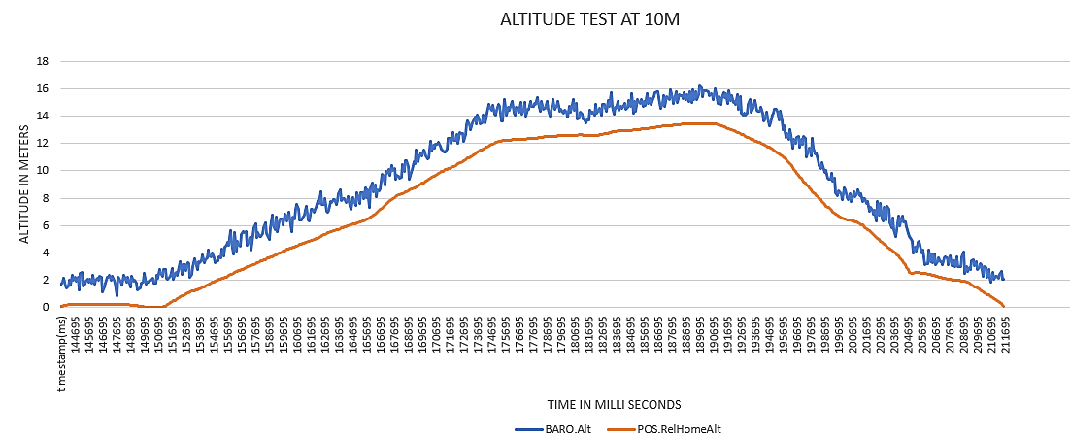

Figure 5.1 Altitude test at 10m

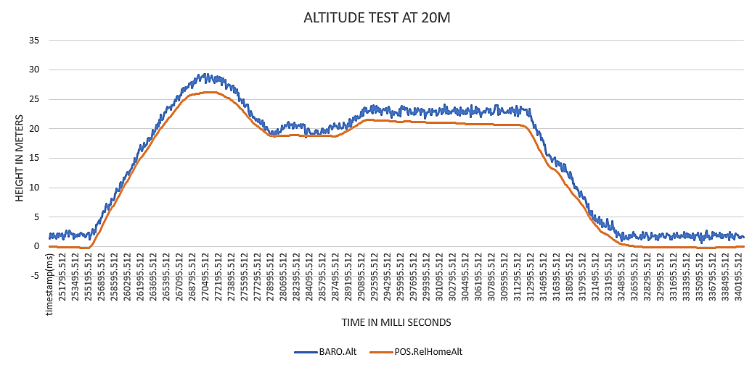

Figure 5.2 Altitude test at 20m

From the above test results it is concluded that, as the altitude increases the standard deviation also increases, because of the air turbulence and wind gusts, decrease in air pressure which decreases sensor accuracy.

### Stability Test

The gyroscope stability must be verified during the stability test in order for the drone to balance and change its speed in response to gyroscopic errors. This test will plot the acceleration graph of along the X, Y, and Z axes and show the stability of the MPU6000 gyroscope at 10 and 20 meters above the ground. The feasible range of acceleration along X, Y, Z axis’s are 0-3m/s2, 0-3.3m/s2, 5-15 3m/s2. The standard deviation is calculated for each of the axis. This test is performed at two different altitudes at 10m and 20m, at wind speed of 13kmph.

**Case 1: Stability test 10m Altitude**

e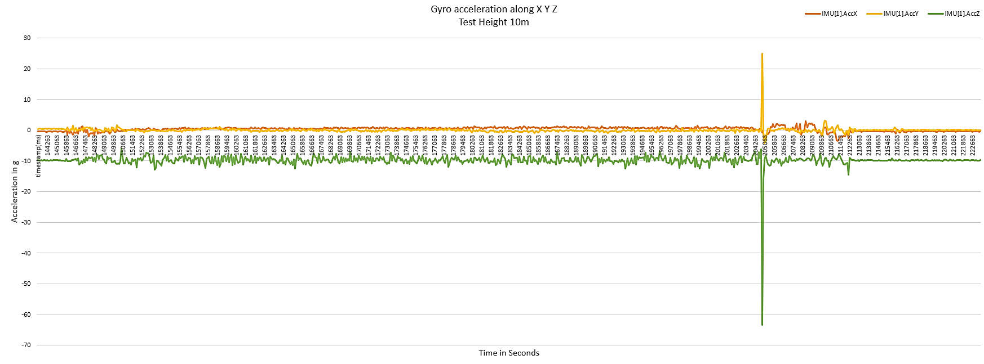

Figure 5.3 Position hold test - 10m Altitude

From the above graph it is observed that the average X-axis acceleration is 0.323m/s2, Y-axis acceleration is -0.0173 m/s2, Z-axis acceleration is -9.8 3m/s2. The standard deviation across X axis, Y axis, Z axis are 0.71, 0.98, 2.12.

**Case 2: Stability test 20m Altitude**

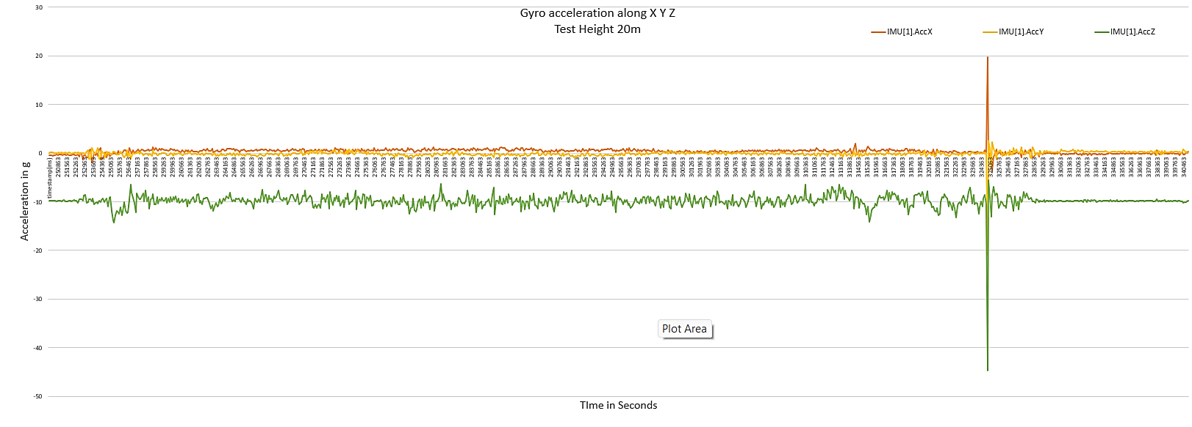

Figure 5.4 Stability test - 20m Altitude

From the above graph 2 it can be seen that the average X-axis acceleration is 0.373m/s2, Y-axis acceleration is -0.1063m/s2, Z-axis acceleration is -9.84 3m/s2.

The standard deviation across X axis, Y axis, Z axis are 0.78, 0.77, 1.53.

From the above observations, it is concluded that the GPS position or the stability does hold at any point of altitude within the range.

### Speed test

An UAV speed test is done in stabilize mode, where it is accelerated at maximum velocity. The quadcopter is initialized in loiter mode and then after turned into SwB2- SwC3 stabilize mode for the purpose of test. The maximum set ground speed of the quadcopter is 10m/s where it can be changed in the mission planner application. The UAV velocity is dependent on the environment wind velocity, if the external wind velocity (air gusts) is high then the flight controller takes time to settle the oscillations and stabilize the drone. The UAV velocity decreases when it is stabilizing, this is done to reduce the damage to the propellers. At higher altitude the drone speed remains same but the stability will be reduced. This test is done at full 100% throttle.

**Case 1: Speed Test At 10m Altitude**

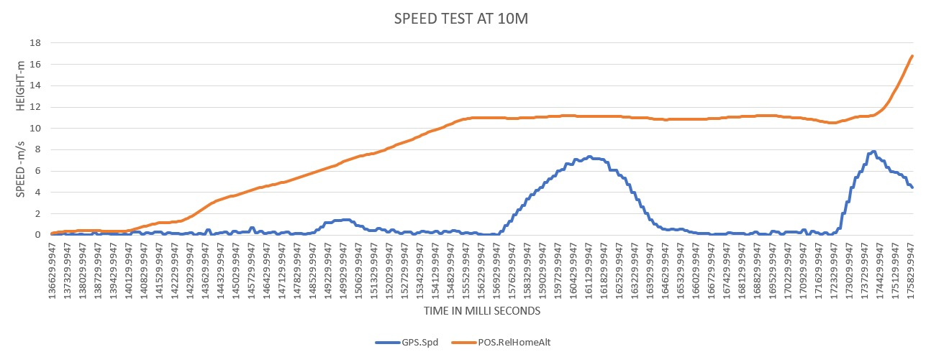

Figure 5.5 Speed Test At 10m Altitude

In the first test case the maximum velocity reached by the quadcopter is 7.80 m/s, Average velocity throughout this test is 2.82 m/s.

**Case 2: Speed Test At 20m Altitude**

In the 20m test the maximum velocity reached by the quadcopter is 7.60 m/s, Average velocity throughout this test is 2.17 m/s.

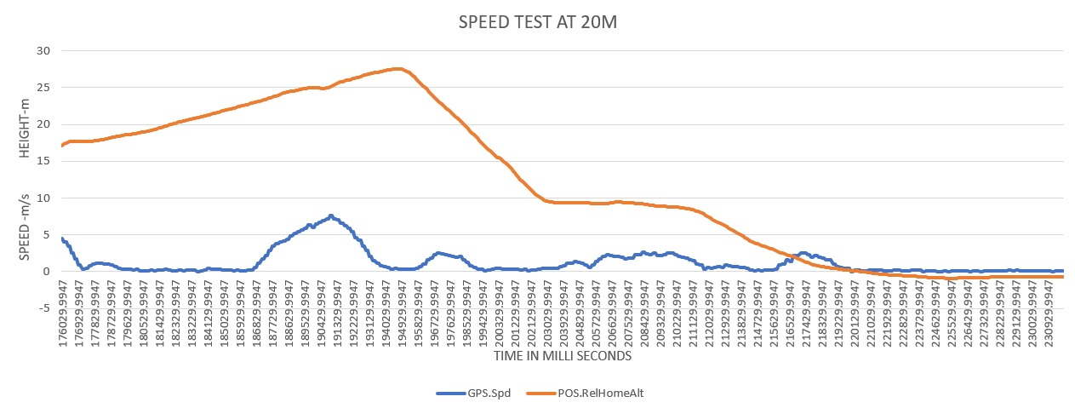

Figure 5.6 Speed Test At 20m Altitude

From the observations it is concluded that, as speed of the drone is dependent on the altitude and also stability. Because as the altitude increase the air density drops which means the propellers have to spin faster to generate the required amount of thrust downwards to hover, due to the higher RPM of motor’s the flight controller will have difficulty to find a stable point.

### Payload Test

Payload test of the UAV is done to determine the maximum weight it can carry. To perform the test the payloads are attached to the bottom of the UAV. The payload weights for the series of the tests are 250g, 300g, 500g.

**Max payload Calculations**

When the thrust is equal to the exact weight of the drone, then the drone is in equilibrium point to hover. For a conventional drone, the thrust should be twice of the weight to obtain flight i.e., thrust to weight ratio is 2:1. For a drone of total weight 1500g including battery, the minimum thrust produced should be 3000g to achieve flight. But the total drone thrust is 3200g.

**Case 1: Payload weight - 500g**

Let’s add 500g to the drone, then the total weight should be 2000g, but the thrust produced is 3200g, the additional thrust required is 800g. so the thrust to weight ratio will decrease to 1.6:1 drone will not able to fly.

**Case 2: Payload weight - 300g**

When 300g added to the drone, then the total weight should be 1800g, but the thrust produced is 3200g, the additional thrust required is 400g. so the thrust to weight ratio is decreased to 1.77:1 drone will achieve partial fly.

**Case 3: Payload weight - 250g**

When 250g added to the drone, then the total weight should be 1750g, but the thrust produced is 3200g, the additional thrust required is 300g. so the thrust to weight ratio is 1.82:1 drone will achieve fly but will not able to fly in full thrust.

**Test observation**

The below test is done in open environment where the moderate wind velocity is 11km/h. Payload test at 500g is done in the first try as to test the maximum allowable weight drone can carry. From the graph in the Figure 5.7, the attitude deviation is 0.82m but the in full thrust it reached 3.56m and immediately descended to the ground. From the graph in Figure 5.8, the drone achieved 5.29 at 75% of the throttle when payload of 300g is added. Due to loosen payload the deviation is higher. The graph in Figure 5.9, the observation of drone achieved 12.03m of altitude at 75% throttle when payload of 250g is added.

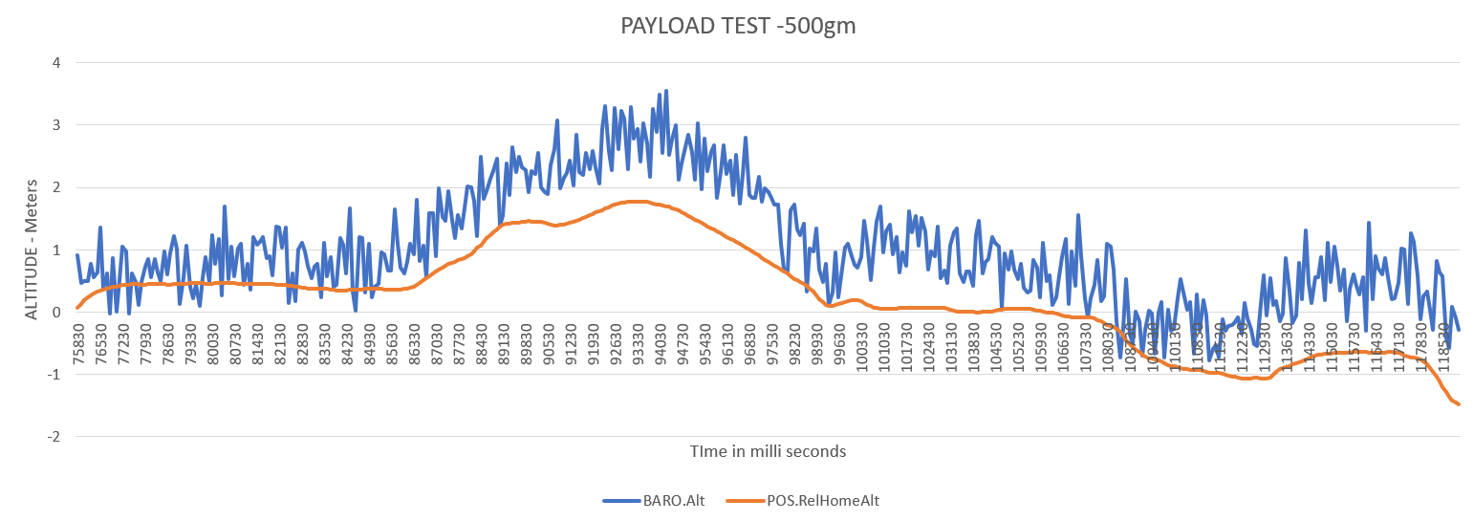

Figure 5.7 Payload test 500g

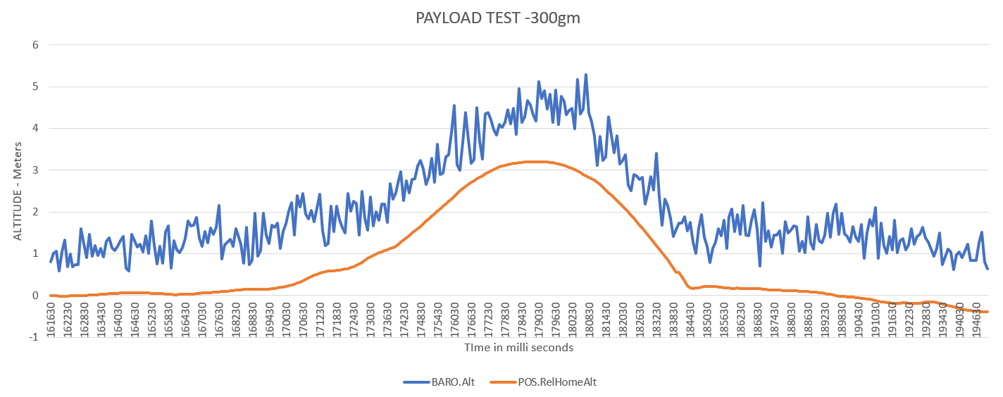

Figure 5.8 Payload test 300g

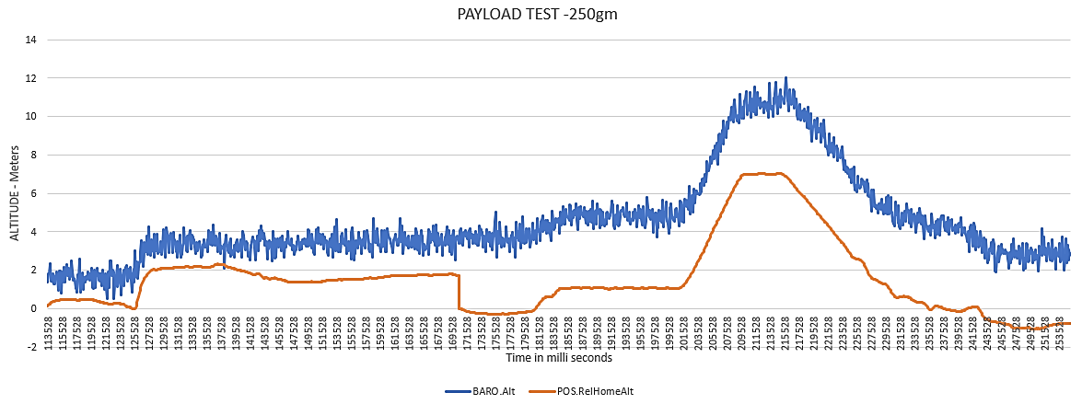

Figure 5.9 Payload test 250g

**Results**

The quadcopter showed effective flight qualities in typical operational settings, holding a constant hover and reacting quickly to directions from ground control. The flight tests also showed that performance varied according to environmental elements including wind direction and speed. While the quadcopter generally exhibited the expected behavior, there were instances where deviations occurred, particularly in gusty wind conditions, these wind gusts lead to the parameter deviation errors.

Such as the altitude deviation at 10 m and 20 m is 25.8, 41.1. The stability of the quadcopter along x, y, z planes is in its respective range. The values of the Acc.x, Acc.y, Acc.z are 0.323m/s2, 0.017 m/s2, -9.8 m/s2. The standard deviation across X axis, Y axis, Z axis are 0.71, 0.98, 2.12. The analysis shows that payload below 250g is more feasible to lift by the drone to achieve altitude and stability with lower deviation.

Despite these limitations, the results of the quadcopter testing offer insightful information about its performance traits and point up areas that require further study. The results are significant because they have the potential to guide the development of quadcopter systems' overall dependability and maneuverability.

It is important to acknowledge the restrictions of the experimental setup and potential causes of error, as well as the limitations of the testing approach. The observed results might have been impacted by variables including pilot competence and sensor accuracy and calibration.

**Conclusion**

In conclusion, the results of the quadcopter testing contribute to our understanding of its behavior in real-world scenarios and offer valuable guidance for future research and development efforts in the field of autonomous aerial systems.

Testing the quadcopter's performance under different flying situations and the UAV's effectiveness were the main objectives. Data was gathered during the testing procedure on variables like flight duration, altitude stability, system response in Acceleration graph. Analysis of the collected data reveals the relations between the parameters. Under normal operating conditions, the quadcopter demonstrated efficient flying characteristics, maintaining a steady hover and responding fast to commands from ground control. The flying tests also revealed that environmental factors, such as wind direction and speed, affected performance. Although the quadcopter generally behaved as planned, there were a few exceptions, especially in settings with strong winds. These wind gusts caused the parameter deviation inaccuracies.